 | 7.1.43 Editors - 3D Viewport - Header - Hair Curve - Sculpt mode - Curves menu
Table of content
Sculpt mode - Curves menu 1
Snap to Deformed Surface 1
Snap to Nearest Surface 1
Convert to Particle System 1

Sculpt mode - Curves menu

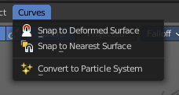
Snap to Deformed Surface
Move curves to the nearest deformed surface so that the first point is exactly on the surface mesh. This re-attaches the curves to a deformed surface using the existing attachment information.
This only works when the topology of the surface mesh has not changed.

Snap to Nearest Surface
Move curves to the nearest surface so that the first point is exactly on the surface mesh. This finds the closest point of the surface of the root point of every curve and moves the root there.

Convert to Particle System
Add a new or update an existing hair particle system on the surface object. The new Particle System is the legacy hair system. This does not remove the hair curve object, but creates/updates a new Particle System.

